s12-Day Gorillas, Chimps & Wildlife Epic Safari

This is a mid-range tour. This 12-day best of Uganda safari offers you an abundance of wildlife, scenery, and cultural experiences. Gorilla, chimp and golden monkey trek may be the highlight of this safari, but there are amazing opportunities for seeing rhinos, lions, hippos, buffaloes, leopards, elephants, several species of birds and an abundance of dense green forest. Enjoy the thundering Murchison Falls in the north of Uganda the crater lakes in the western and southwestern of the country.

Route
Uganda
Start | Entebbe (Day 1)
Day 2-3 | Murchison Falls NP
Day 4-5 | Kibale NP (Chimps)
Day 6-7 | Queen Elizabeth NP
Day 8-9 | Bwindi Impenetrable NP (Gorillas)
Day 10 | Mgahinga Gorilla NP (Gorillas)
Day 11 | Lake Mburo NP
End | Entebbe (Entebbe) (Day 12)

Tour Features

Mid-range tour
This mid-range tour uses lodges and hotels.

Private tour
This tour will be organized exclusively for you and won't be shared with others.

Can start any day
If availability permits, this tour can start on any day.

Can be customized
You can request minor changes to the accommodations and destinations of this tour.

Suitable for solo travelers
Solo travelers can book this private tour.
15

Minimum age of 15 years
The minimum age for this tour is 15 years.

Activities & Transportation

Activities: game drives, gorilla trekking, chimpanzee trekking & boat trip

Game drives: pop-up roof 4x4 vehicle

Getting around: pop-up roof 4x4 vehicle, boat & hiking/walking

A transfer from and back to the airport is included

Accommodation & Meals
- Additional accommodation before and at the end of the tour can be arranged for an extra cost
- Day
Accommodation
Meals
- 1
Jet Villas EntebbeMid-range hotel in Entebbe (City)

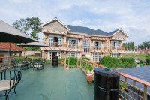

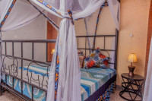

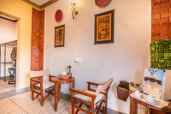

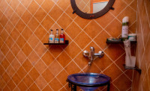+9Photos

Breakfast Included
- 2-3
Pakuba Safari LodgeMid-range lodge inside Murchison Falls NP

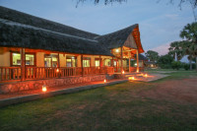

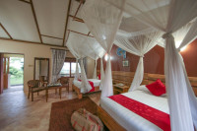

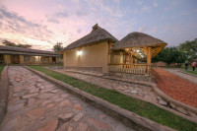

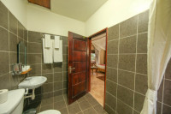+4Photos

All Meals Included
- 4-5
Isunga LodgeMid-range lodge just outside Kibale NP (Chimps)

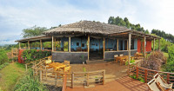

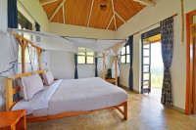

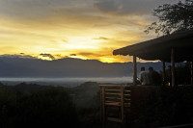

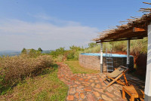+8Photos

All Meals Included
- 6-7
The Bush Lodge (Banda)Mid-range banda just outside Queen Elizabeth NP

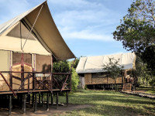

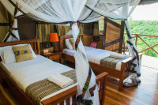

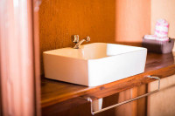

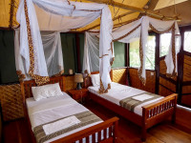+7Photos

All Meals Included
- 8-9
Bweza Gorilla LodgeMid-range lodge just outside Bwindi Impenetrable NP (Gorillas)

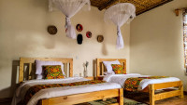

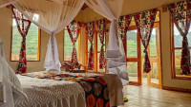

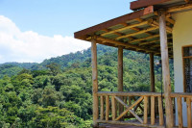

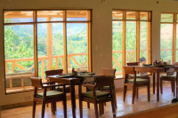

All Meals Included
- 10
Lake Mulehe Safari LodgeMid-range lodge less than 1hr drive from Mgahinga Gorilla NP

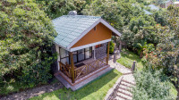

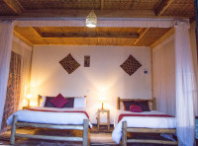

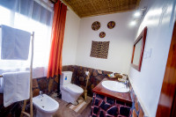

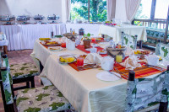+5Photos

All Meals Included
- 11
Rwakobo Rock LodgeMid-range lodge just outside Lake Mburo NP

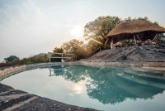

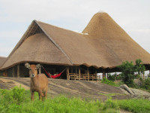

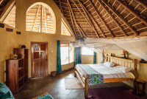

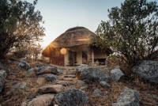+6Photos

All Meals Included
- 12
End of tour
(No accommodation)
All Meals Included

Day by day
- You'll be collected from the airport.
- Accommodation before the tour starts can be arranged for an extra cost.
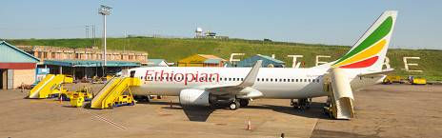

Day 1

Arrival for Best of Uganda Safari
Our friendly guide will welcome you to Uganda at Entebbe Airport and transfer you to your hotel in Kampala or Entebbe. Enjoy the fresh breeze from Lake Victoria, the 2nd largest lake in the world. Get a good night’s rest, your adventure starts the next day.
Main Destination:
Entebbe (City)
Accommodation:
Jet Villas Entebbe
- Mid-range hotel located in Entebbe (City)







+9Photos

Meals & Drinks:
- Breakfast (Lunch & dinner not included)
- Drinking water (Other drinks not included)
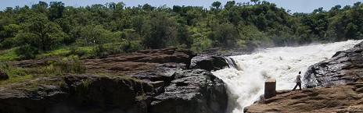

Day 2

Rhino Tracking at Ziwa Rhino Sanctuary
Have an early breakfast and depart for Murchison Falls National Park. The journey is a magical adventure with a stopover at Ziwa Rhino Sanctuary to track rhinos.
Continue on to Murchison Falls and proceed to the top of the falls where you will behold the Nile as it's forced through a 7-meter gorge with a thunderous fall before your very own eyes.
Main Destination:
Murchison Falls National Park
Best Time To VisitDecember to February (Easier to spot animals)
High SeasonJune to September (Peak time for Uganda)
Best WeatherJune and July (Less rain and lower temperatures)
Accommodation:
Pakuba Safari Lodge
- Mid-range lodge located inside Murchison Falls NP







+4Photos

Meals & Drinks:
- All meals included
- Drinking water (Other drinks not included)
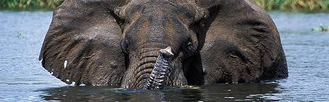

Day 3

Murchison Falls National Park Game Drive
Murchison Falls National Park is the biggest park in Uganda offering fulfilling game viewing. After an early breakfast, we will start the day with a game drive on the northern bank of the River Nile. Look out for giraffes, elephants, hartebeests, buffaloes, leopards, lions and different bird species.
Indeed, it is a privilege to watch wild animals in their habitat as they eat, play, and protect the young. In the afternoon, the safari will continue on River Nile. The relaxed boat safari provides more opportunities for spotting a variety of animals and birds. Watch the water the Murchison Falls, the ‘devils cauldron’. This kind of boat cruise is only found in Uganda in the whole of Africa.
Main Destination:
Murchison Falls National Park
Accommodation:
Pakuba Safari Lodge
- Mid-range lodge located inside Murchison Falls NP
Meals & Drinks:
- All meals included
- Drinking water (Other drinks not included)
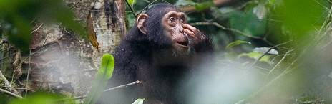

Day 4

Transfer to Kibale Forest National Park
Today we will depart to the home of chimpanzees in Kibale National Park—the primate capital of East Africa. Kibale Forest is home to 13 species of primates with the main attraction being chimpanzee tracking. On this journey, you'll have stunning views as you pass small villages, local markets and several birdlife. This is a day’s trip with packed lunch or in a town en-route.
Main Destination:
Kibale National Park (Chimps)
Best Time To VisitJanuary to February and June to July (Chimp trekking is easiest)
High SeasonJune to September (Peak time for Uganda)
Best WeatherJanuary to February and June to July (Least rain)
Accommodation:
Isunga Lodge
- Mid-range lodge located just outside Kibale NP (Chimps)





+8Photos

Meals & Drinks:
- All meals included
- Drinking water (Other drinks not included)
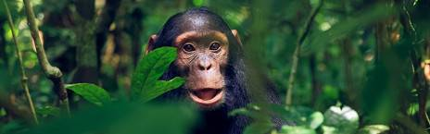

Day 5

Chimpanzee Trekking in Kibale Forest National Park
Kibale National Park is the primate capital of East Africa. Chimpanzee trekking is a fulfilling adventure that takes you deep in the tropical forest across streams of water. You may also have sightings of red-tailed monkeys, black and white Columbus monkeys, butterflies, and birds calling from the canopies. With the help of your guide, you will locate the chimps. Enjoy picture moments and watch them as they play and feed. After lunch, visit Bigodi Village and the swamp known for its rich diversity of birds and primates depending on the availability of time.
Main Destination:
Kibale National Park (Chimps)
Accommodation:
Isunga Lodge
- Mid-range lodge located just outside Kibale NP (Chimps)
Meals & Drinks:
- All meals included
- Drinking water (Other drinks not included)
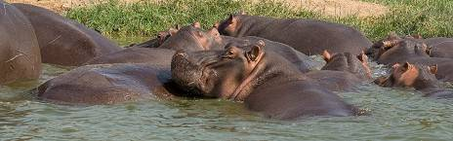

Day 6

Transfer to Queen Elizabeth National Park
Today after breakfast, our tour continues to Queen Elizabeth National Park. Enjoy views of several crater lakes and the mystical Rwenzori Mountain Ranges en-route. On arrival in the park, we shall have a small game drive as we proceed to the lodge for lunch and a boat cruise on the Kazinga Channel. The boat safari offers you great photo sessions in a relaxed way with lots of birdlife on the shores, crocodiles and elephants.
Main Destination:
Queen Elizabeth National Park
Best Time To VisitJanuary to February and June to July (Dry seasons)
High SeasonJune to September (Peak time for Uganda)
Best WeatherJune to July and January to February (Less rainfall)
Accommodation:
The Bush Lodge (Banda)
- Mid-range banda located just outside Queen Elizabeth NP



Meals & Drinks:
- All meals included
- Drinking water (Other drinks not included)

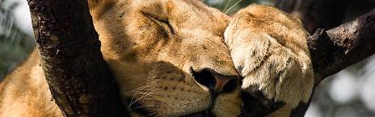

Day 7

Wildlife Safari in Queen Elizabeth National Park
The animals in their different families, clans, and groups are out starting on their day. Notice the difference between the animals in their natural habitat and those caged in zoos. Have a game drive in Kasenyi plains in the open-roof safari cars. Proceed to Ishasha, famed for the tree-climbing lions and search for them with help of rangers. Lunch will be a picnic or at the lodge.
Main Destination:
Queen Elizabeth National Park
Accommodation:
The Bush Lodge (Banda)
- Mid-range banda located just outside Queen Elizabeth NP
Meals & Drinks:
- All meals included
- Drinking water (Other drinks not included)
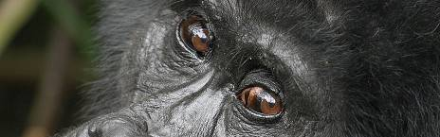

Day 8

Expedition To Bwindi Impenetrable Forest National Park
Today we will start our journey to the home of the gentle giants of Bwindi. This fulfilling journey takes us through the Kigezi Highlands with great scenery of terraced hills. Lunch will be along the way or at the lodge depending on the time of your arrival. You'll lodge in or adjust to the impenetrable forest. This will offer you great resting as you prepare for the next day’s trek.
Main Destination:
Bwindi Impenetrable National Park (Gorillas)
Best Time To VisitJune to August and December to February (Gorilla trekking is easiest)
High SeasonJune to September (Gorilla permits are scarce)
Best WeatherJune to July and December to February (Less rainfall)
Accommodation:
Bweza Gorilla Lodge
- Mid-range lodge located just outside Bwindi Impenetrable NP (Gorillas)



Meals & Drinks:
- All meals included
- Drinking water (Other drinks not included)

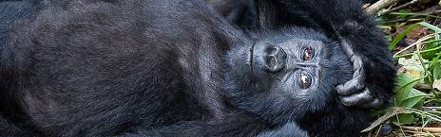

Day 9

Gorilla Trekking in Uganda
The highlight of your safari will be meeting the gentle giants of Bwindi Impenetrable National Park! Enjoy the fullness of the impenetrable forest abounding with life, host to several species of birds, butterflies, primates and mammals. Eventually, with the help of your guide who is also a park ranger. You will find yourself face to face with the enormous and rare mountain gorillas. The trekking experience takes anything from one hour (rarely) to about 8 hours to accomplish. However, you only have one hour with gorillas to capture your finest moment. Suggested activities for those not interested in gorilla tracking are a community village walk or a short guided forest walk.
Main Destination:
Bwindi Impenetrable National Park (Gorillas)
Accommodation:
Bweza Gorilla Lodge
- Mid-range lodge located just outside Bwindi Impenetrable NP (Gorillas)
Meals & Drinks:
- All meals included
- Drinking water (Other drinks not included)

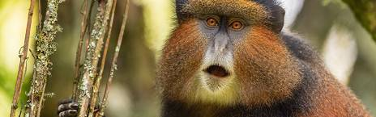

Day 10

Golden Monkey trekking in Mgahinga national park
Early morning drive from Bwindi and head to Mgahinga gorilla national park. This is about 2 hours drive. Embark on golden monkey trekking. This trekk will take you to the golden monkeys, an endemic species of Mgahinga Gorilla National Park in southwestern Uganda, you will trekk through the jungles of Mgahinga National park, consisting of bamboo and a variety of indigenous plants like giant lobelia. Your ranger guide will tell you about the national park’s history and the fauna and flora that the park holds during the trekk. The trek takes about 2-3 hours, Get back to your reserved accomodation for an overnight stay.
Main Destination:
Mgahinga Gorilla National Park (Gorillas)
Best Time To VisitJune to August and December to January (Gorilla trekking is easiest)
High SeasonJune to September (Gorilla permits are scarce)
Best WeatherJun to Aug and Dec to Jan (Less rainfall)
Accommodation:
Lake Mulehe Safari Lodge
- Mid-range lodge located less than 1hr drive from Mgahinga Gorilla NP



Meals & Drinks:
- All meals included
- Drinking water (Other drinks not included)

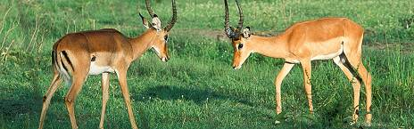

Day 11

Lake Mburo National Park for Wildlife
The journey to Lake Mburo National Park is through beautiful landscapes, plantations, and farms. Have a visit to a Cultural Museum—exhibiting the life of the native people of the area. Have lunch/picnic at a restaurant along the way. Arrive in the park later that afternoon and take a boat trip on Lake Mburo.
Main Destination:
Lake Mburo National Park
Best Time To VisitJanuary to February and June to August (Dry seasons)
High SeasonJune to September (Peak time for Uganda)
Best WeatherJune to August and January to February (Little rainfall)
Accommodation:
Rwakobo Rock Lodge
- Mid-range lodge located just outside Lake Mburo NP



+6Photos

Meals & Drinks:
- All meals included
- Drinking water (Other drinks not included)
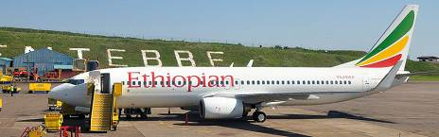

Day 12

Transfer to Entebbe
After an early breakfast, we will go on a game drive in Lake Mburo National Park. We will later head to Entebbe, with a stopover at the famed Equator line. Have lunch and then proceed to the airport arriving in the afternoon.
Main Destination:
Entebbe International Airport (Entebbe)
Accommodation:
No accommodation (End of tour)
Meals & Drinks:
- All meals included
- Drinking water (Other drinks not included)

End of tour

Additional accommodation can be arranged for an extra cost.
- You'll be dropped off at the airport.

Rates

Important to Know
- Rates are per person and exclude the international flight from/to your home country.
- This tour accepts children who are 15 years and older.

Rates Per Person
Start dates | Solo1 room | 2 people1 room | 3 people2 rooms | 4 people2 rooms | 5 people3 rooms | 6 people3 rooms
Jan 1, 2026 - Dec 31, 2026 | $5,600 | $3,950 | $3,785 | $3,500 | $3,433 | $3,235
Jan 1, 2027 - Dec 31, 2027 | $5,600 | $3,950 | $3,785 | $3,500 | $3,433 | $3,235

Included
- Park fees (For non-residents)
- Gorilla permits (One per person, non-resident)
- Chimp permits (One per person, non-resident)
- All activities (Unless labelled as optional)
- All accommodation (Unless listed as upgrade)
- A professional driver/guide
- All transportation (Unless labelled as optional)
- All Taxes/VAT
- Roundtrip airport transfer
- Meals (As specified in the day-by-day section)
- Drinking water (On all days)

Excluded
- International flights (From/to home)
- Additional accommodation before and at the end of the tour
- Tips (Tipping guideline US$10.00 pp per day)
- Personal items (Souvenirs, travel insurance, visa fees, etc.)
- Government imposed increase of taxes and/or park fees

